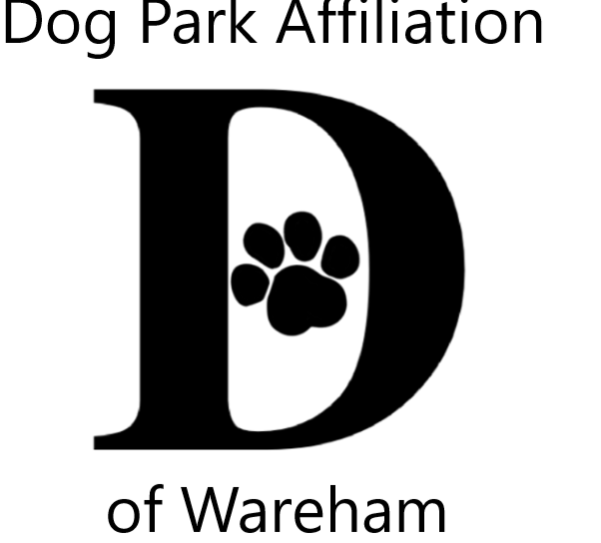 DPAW’s 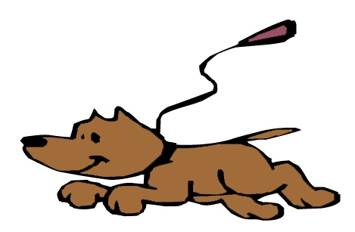Unleash the PAWsibilities

Contest tips

Your animal can be…

Your pet, or more than one pet

Family & neighbor’s pets

Backyard bugs, butterflies, birds, squirrels

Wildlife in your neighborhood, or walks to the woods & beaches

If you went fishing

From a book, movie or program you enjoyed

An animal you love to research

A wished for pet, a pet you daydream about

Can be just your animal, or include you, family &/or friends

Wareham Dog Park opens this Fall Imagine celebrating pups

Visual Arts

Any material, can mix media

Any style

Drawing, painting, graphics, fabric, collage, cartoon, photography, mixed

Must be 2 dimensional – FLAT so it can fit in the slot in the box & hang on a wall

No larger than 9x12”

Literary Arts

Poetry, song lyrics, short story, description, essay, letter to animal

Must fit on one page so it can hang on a wall

