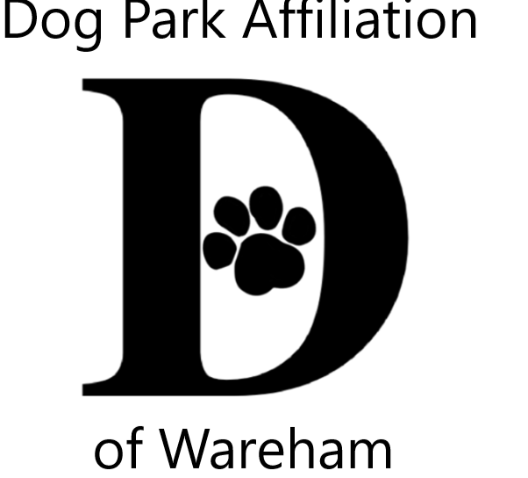 DPAW’s 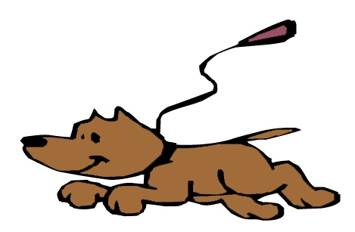Unleash the PAWsibilities 4
Visual & Literary Youth Creative Arts Contests Celebrating the People-Animal Bond
Themes
All creatures great & small
OR
Wareham Dog Park opening PAWty

Visual Arts Contest – 2 dimensional (flat), any media, mixed media, no larger than 9x12
Literary Arts Contest – poetry, narrative/story, letter, song lyrics, essay or descriptive, Limit to one page
YOU CAN ENTER BOTH VISUAL & LITERARY CONTESTS

Jurors from art & literary fields 3 age groups; 5-8, 9-12, 13-16
All contestants entered into a prize pool raffle Winners also receive trophies

Accepting submissions from July 6th thru August 10th
Wareham Free Library Gleason Family Y, Wareham
Onset Bay Association, Onset TD Bank, Wareham

Family Celebration August 26th Gleason Family YMCA at 4:30
Gallery at Wareham Main St. Post Office
Questions contact sammorrison@comcast.net

Sponsored by Dog Park Affiliation of Wareham (DPAW) www.warehamdogpark.org for more details
Submissions become property of DPAW for promotions, acknowledgments & fundraising
------------------------------------------------------------------------------------------------
Attach to back of submission with scotch tape OR print info in pencil (Not marker/pen to protect work) PLEASE PRINT

Name: _________________________________________________ Age: ______

Parent/Guardian for 5-14 (Print name & signature): _______________________________________________

Phone #: _______________________________ Title of Piece (optional) : ___________________________

