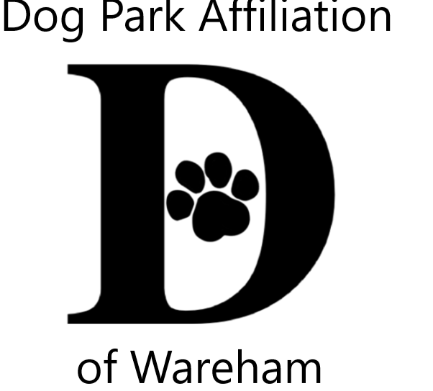 DPAW’s 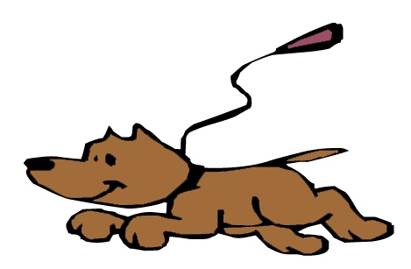Unleash the PAWsibilities II
Youth Art & Literary Contests Celebrating the People-Pet Bond
Theme – Animals, Our COVID Companions
Pets & wildlife bringing us comfort & joy during quarentine

Visual Arts Contest – 2 dimensional (flat), any media, no larger than 9x12
Literary Arts Contest – poetry, narrative/story, letter, essay or descriptive, limited to one page
YOU CAN ENTER BOTH VISUAL & LITERARY CONTESTS

Jurors from art & literary fields for 3 age groups; 5-9, 10-14, 15-18
All contestants entered into a prize pool raffle Winners also receive trophies

Accepting submissions from July 7th thru August 7th
Outdoor contactless drop off box sites @ Wareham Main St. Post Office, Spinney Library & Decas School
Celebration site & activities pending Governor’s COVID Guildlines for mid-August
Gallery of all work @ Main St Post Office & WCTV On Demand
Questions contact sammorrison@comcast.net

Sponsored by Dog Park Affiliation of Wareham (DPAW) www.warehamdogpark.org
Submissions become property of DPAW for promotions, acknowledgments & fundraising
------------------------------------------------------------------------------------------------
Attach to back of submission with scotch tape or print info in pencil to protect your work. PLEASE PRINT

Name: _____________________________________ Age: ______

Parent/Guardian for 5-14 (Print name & signature): ______________________________________________

Phone #: _______________________________ Title of Piece (optional) : ___________________________

