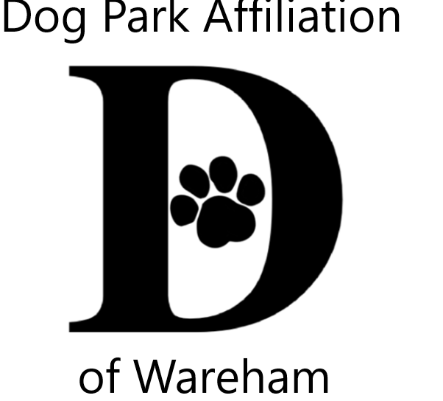 DPAW’s 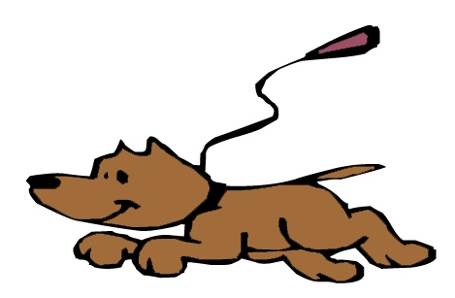Unleash the PAWsibilities III
Visual & Literary Youth Creative Arts Contests Celebrating the People-Pet Bond
Themes – Animals, Our COVID Companions Year 2
Pets & wildlife bringing us comfort & joy during the long quarantine
OR
Celebrating the end of quarantine with our animal friends.

Visual Arts Contest – 2 dimensional (flat), any media, mixed media, no larger than 9x12
Literary Arts Contest – poetry, narrative/story, letter, lyrics, essay or descriptive, limited to one page
YOU CAN ENTER BOTH VISUAL & LITERARY CONTESTS

Jurors from art & literary fields 3 age groups; 5-9, 10-14, 15-18
All contestants entered into a prize pool raffle Winners also receive trophies

Accepting submissions from July 6th thru August 6th
Decas School Cafeteria ((Summer Lunch Program) & Wareham Free Library, Wareham
Onset Bay Association, Onset Soule Homestead, Middleboro Music of the Bay, Buzzards Bay
Check warehamdogpark.org for drop off days/hours
Family Celebration August 20th @ 4:30 on Decas School grounds Rain date August 27th
Gallery @ Wareham Main St. Post Office & WCTV On Demand
Questions contact sammorrison@comcast.net

Sponsored by Dog Park Affiliation of Wareham (DPAW) www.warehamdogpark.org for more details
Submissions become property of DPAW for promotions, acknowledgments & fundraising
------------------------------------------------------------------------------------------------
Attach to back of submission with scotch tape OR print info in pencil (to protect your work). PLEASE PRINT

Name: _________________________________________________ Age: ______

Parent/Guardian for 5-14 (Print name & signature): _______________________________________________

Phone #: _______________________________ Title of Piece (optional) : ___________________________

