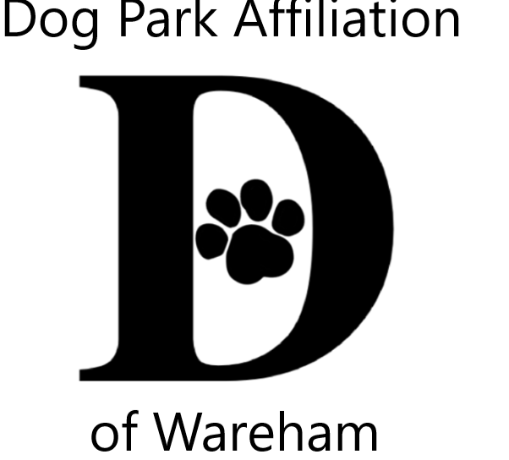DPAW’s 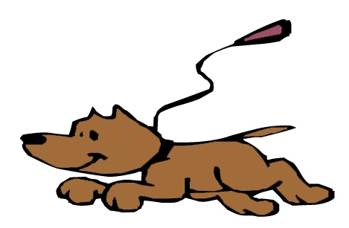Unleash the PAWsibilities
Area Youth Art & Literary Contests
2023 Themes
Flip, Flop & Fly –Celebrating creatures great & small
OR
Who Let the Dogs Out? Wareham Dog Park is open

Jurors from art & literary fields for 3 age groups
Ages; 5-8 9-12 13-16

Visual Art
2 dimensional (flat), any media/style,mixed media, no larger than 9x12
Literary
poetry, short story, lyrics, letter, descriptive, essay

ALL contestants entered into a prize pool raffle
One entry per category
Enter BOTH VISUAL & LITERARY CONTESTS to increase your chances!
Winners also receive trophies

More contest info, tips & registration forms
warehamdogpark.org

Submissions accepted from July 6th thru August 7th

Submission Sites
Wareham Free Library Gleason Family YMCA Wareham TD Bank
Onset Bay Association Spinney Library, Onset
Submissions become property of DPAW

Family Celebration at Gleason Family YMCA August 18th @ 4:30
Late Summer Gallery of all entries @ Wareham Main St Post Office

Questions contact sammorrison@comcast.net

Sponsored by Dog Park Affiliation of Wareham (DPAW)
Wareham Cultural Council Facchetti & Facchetti

