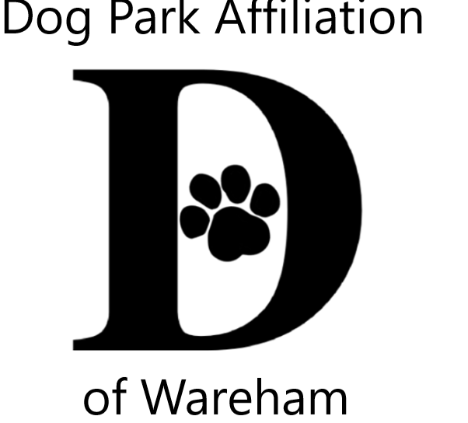 DPAW’s 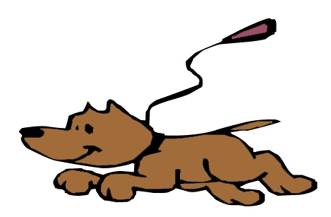Unleash the PAWsibilities

Contest tips

Your animal can be…

Your pet, or more than one pet

Family & neighbors pets

Backyard bugs, butterflies, birds, squirrels

Wildlife in your neighborhood, or walks to the woods & beaches

If you went fishing

From a book, movie or program you enjoyed

An animal you love to research

A wished for pet, a pet daydream about

Can be just your animal, or include you, family &/or friends

Visual Arts

Any materials

Any style

Must be 2 dimensional – FLAT so it can fit in the slot in the box & hang on a wall

No bigger than 9x12”

Literary Arts

Poetry, short story, description, essay, letter

Must fit on one page so it can hang on a wall

IF YOU ENTER BOTH CONTESTS, TWO RAFFLE CHANCES.

