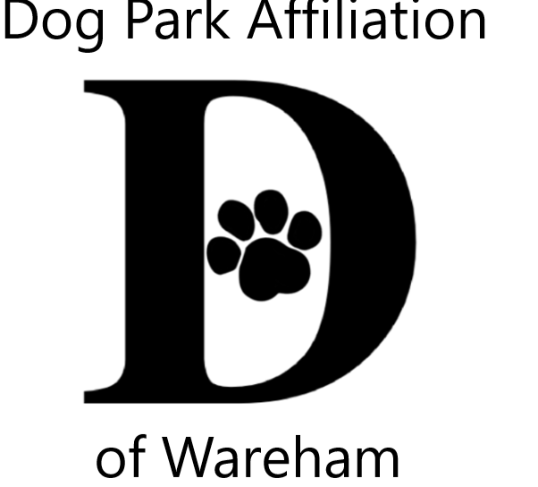DPAW’s 5th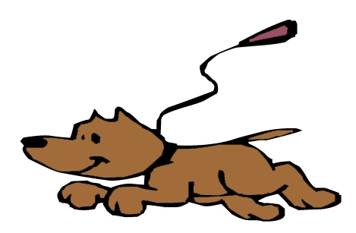Unleash the PAWsibilities
Visual & Literary Youth Creative Arts Contests Celebrating the People-Animal Bond
Themes
Flip, Flop & Fly, Wareham’s So Alive! – Celebrating creatures great & small
OR
Who Let the Dogs Out? – Wareham Dog Park is opened

Visual Arts Contest – 2 dimensional (flat), any media, mixed media, no larger than 9x12
Literary Arts Contest – poetry, narrative/story, letter, song lyrics, essay, or descriptive
YOU CAN ENTER BOTH VISUAL & LITERARY CONTESTS ONE Entry PER CATEGORY

Jurors from art & literary fields 3 age groups; 5-8, 9-12, 13-16
All contestants entered into a prize pool raffle Winners also receive trophies

Accepting submissions from July 6th thru August 7th
Wareham Free Library TD Bank, Wareham Gleason Family Y, Wareham
Onset Bay Association

Family Celebration 18th Gleason Family YMCA at 4:30
Gallery at Wareham Main St. Post Office for the month of September
Questions contact sammorrison@comcast.net

Sponsored by Dog Park Affiliation of Wareham (DPAW) www.warehamdogpark.org for more details
Submissions become the property of DPAW for promotions, acknowledgments & fundraising
------------------------------------------------------------------------------------------------
Attach to the back of the submission with scotch tape OR print info in pencil (Not marker/pen to protect work) PLEASE PRINT

Name: _________________________________________________ Age: ______

Parent/Guardian for 5-14 (Print name & signature): _______________________________________________

Email (celebration reminder/trophy, prize notification): ___________________________________Phone #: _____________________

