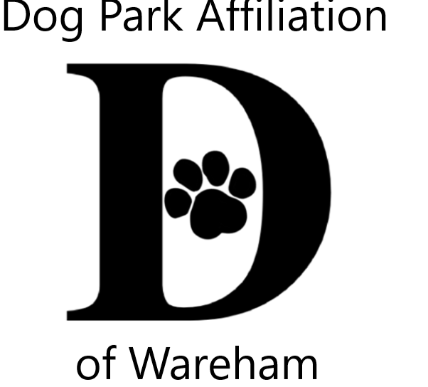 DPAW’s 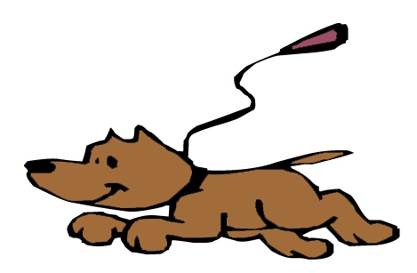Unleash the PAWsibilities
Area Youth Art & Literary Contests
Celebrating the People-Pet Bond

2020 Theme – Animals, Our COVID Companions
Animals (pets, wildlife) bringing us comfort & joy during quarentine

Jurors from art & literary flield for 3 age groups
Ages; 5-9 10-14 15-18

Visual Art
2 dimensional (flat), any media/style, no larger than 9x12
Literary
poetry, short story, letter, descriptive, essay limited to one page

ALL contestants entered into a prize pool raffle
Enter BOTH VISUAL & LITERARY CONTESTS to increase you chances!
Winners also receive trophies

Contest Info & Registration Form
www.warehamdogpark.org

Submission accepted from July 6th thru August 7th

Outdoor contactless drop off box sites
Wareham Main St Post Office Decas School Spinney Library
Submissions become property of DPAW

Late Summer Gallery of all entries
Wareham Main St Post Office WCTV On Demand
;
Contest & raffle winners announced August 17th
Time & place TBD based on COVID guidelines at that time

Questions & contest info
sammorrison@comcast.net

Sponsored by Dog Park Affiliation of Wareham (DPAW)

