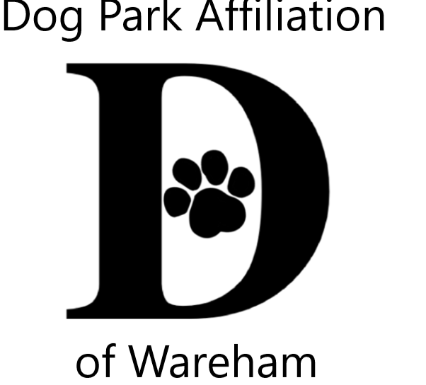 DPAW’s 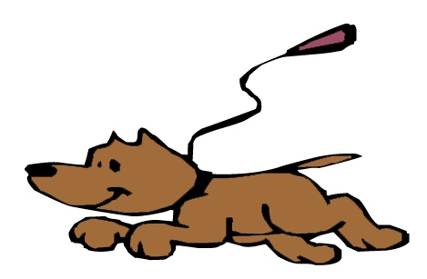Unleash the PAWsibilities
Area Youth Art & Literary Contests

2021 Themes – Animals, Our COVID Companions Year 2
Pets & wildlife bringing us comfort & joy during the long quarantine
OR
Celebrating the end of quarantine with our animal friends

Jurors from art & literary fields for 3 age groups
Ages; 5-9 10-14 15-18

Visual Art
2 dimensional (flat), any media/style,mixed media, no larger than 9x12
Literary
poetry, short story, lyrics, letter, descriptive, essay limited to one page

ALL contestants entered into a prize pool raffle
Enter BOTH VISUAL & LITERARY CONTESTS to increase your chances!
Winners also receive trophies

More contest Info & Registration Form
www.warehamdogpark.org

Submissions accepted from July 6th thru August 6th

Submission sites
Decas School & Wareham Free Library Onset Bay Association
Soule Homestead, Middleboro Music of the Bay, Buzzards Bay
Submissions become property of DPAW

Family celebration is August 20th 4:30 on Decas School grounds
^{Rain date Ausgust 27th}
Late Summer Gallery of all entries
Wareham Main St Post Office WCTV On Demand
;

Questions & contest info sammorrison@comcast.net

Sponsored by Dog Park Affiliation of Wareham (DPAW)

